Improving External Extraction Efficiency of Electro-luminescence of Organic LEDs

John Ho
6.191 Preliminary Thesis Proposal
Thesis Advisor: Professor Vladimir Bulovic
Graduate Student Mentor: Seth Coe
Sodini, Shrobe, Chen, Lefian
December 7th, 2001
I. Laboratory of Organic Opto-Electrics (LOOE)

ACADEMIC AND RESEARCH STAFF
Professor Vladimir Bulovic

GRADUATE STUDENTS
Seth Coe, Conor Madigan, Debbie Mascaro

Research Themes
LOOE is a new group at MIT studying the physical properties of organic thin films, structures, and devices. Their fundamental findings are applied to the development of optoelectronic, electronic, and photonic organic devices of nano-scale thickness, including visible LEDs, lasers, solar cells, photodetectors, transistors, and flexible and transparent optoelectronics. In addition to working on small-molecular-weight van-der-Waals-bonded organic thin films, LOOE in the future will also examine polymer solids, self-assembled materials, and hybrid organic/inorganic structures. The aim is to reduce the size of active organic layers from the present nano-scale thickness of organic thin films to that of single molecules, with the ultimate goal of probing functionality of single molecules or polymer strands. Integral to this research is development of new methods for materials growth and techniques for directed nano-scale patterning over large areas. With the present rapid pace of scientific discovery, the use of organic electronic and photonic devices in our everyday lives appears inevitable, although a great deal of research and development still must be accomplished. Development of each new organic device demonstrates the immense versatility of these materials, but simultaneously opens new questions into the origins of the observed physical processes. Hopefully, LOOE’s research efforts will answer some of these riddles and lead to new venues of scientific endeavor.

Lab Facilities
LOOE’s research facilities are located in the Research Lab of Electronics (RLE) and the Center for Materials Science and Engineering (CMSE). The optical characterization lab houses a spectroscopy setup capable of detecting spectral response at very low light intensities. The materials growth and characterization lab presently enables growth of molecular and polymeric organic thin films and structures under controlled inert atmosphere. LOOE is in the process of expanding the integrated growth system and combining the conventional materials growth techniques with novel deposition methods developed in the laboratories. The completed growth system will integrate the method for physical and vapor phase deposition of hybrid organic/inorganic thin-films with a low-pressure RF/DC sputtering chamber, an evaporative growth chamber, and a chemical vapor deposition chamber. The completed vacuum system will be capable of depositing molecular organics, polymers, metals, metal oxides, inorganic nanodots, and colloids in a controlled layer-by-layer fashion. An in-situ shadow masking system will enable fabrication of complex patterned structures inside a vacuum environment, while the integrated N2-filled, dry glove box will facilitate handling, measuring, and packaging of organic thin film samples that are susceptible to reactions with atmospheric oxygen and water vapor.

II. Technology

My MEng thesis hopes to exploit the technological benefits of integrated microspherical lenses in improving the efficiency of Organic LED’s (OLEDs). Currently, OLEDs tend to harness only 20% of the total light emitted from an organic light source and redirect it towards the viewer. In the schematic below imagine that what is drawn represents a single pixel of an OLED display. The drawing of a representative path of a light beam as it travels through the OLED structure demonstrates exactly why this happens. As the light is emitted from the organic layer it travels in all directions. Because of the changes in the index of refraction (n) from layer to layer, the light emitted from the source will refract. Some of the light emitted at shallower angles may become guided in the structure and will be emitted from the substrate edge rather than in the normal direction. 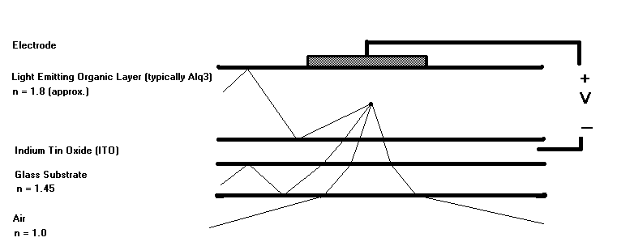
Now, a possible solution to this problem would be to add a glass lens to the glass surface of the OLED pixel, which would help to retain more of the light for viewing as seen below. However, in order to be useful the lens would have to be relatively huge in size as compared to the thickness of the actual OLED pixel. This would make any sort of pixelized display using this solution inherently larger and defocused. The reason the lens needs to be so big is because it is far away from the origin of the light, making the radius of the lens required to bend the same amount of light much larger than one that is closer. Thus, there becomes an impetus to reduce this distance from the lens to the light-emitting layer. 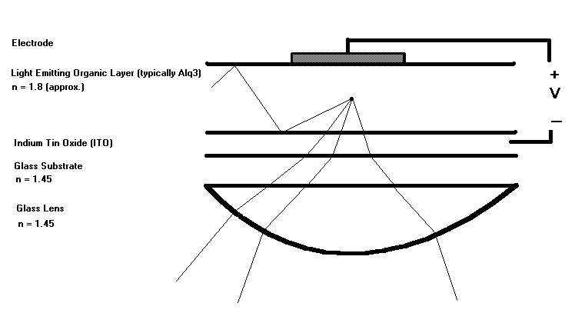
Thus, a possible solution to the efficiency problem, backed by mathematical calculation, comes from moving the lens much closer to the light source. Not only does this make the required lens much smaller and keep the viewing surface completely flat, but also is able to harness more of the emitted light before much of it can be trapped between the glass substrate. Therein lies the tremendous expected boost to efficiency I will be looking for. The trick to moving the lens inside the OLED structure is finding the right material, structures, and processes to produce consistently excellent results. A possible schematic is shown below.
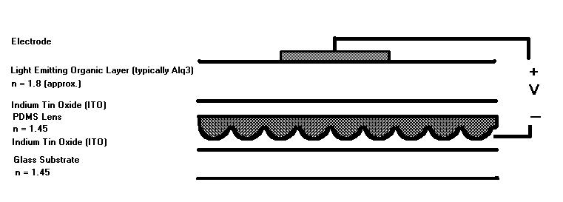

Poly Di-Methyl Siloxane (PDMS) will be used to make the integrated microspherical lenses. There are several properties of this silicone polymer that make it perfect for integration in an OLED structure. First, the PDMS has the ability to conform to shapes on the sub-micron scale and cure without volumetric loss. Second, the PDMS exhibits memorylessness and will retain its shape even after stretching, heating, and cooling. Lastly, the index of refraction of PDMS is almost exactly the same as it is in glass.

In trying to build the best possible lens there is much research that must be done into preparation of PDMS molds, perfecting/inventing new deposition techniques for PDMS and organic materials, and developing reliable models for understanding the new OLED structure.

III. Demonstration

There are a couple of demonstrations that could develop as a result of this research, depending on how far along I manage to get. The ultimate goal would be to demonstrate, with a side-by-side comparison, a finished OLED device that exhibits better external extraction efficiency of light with an OLED without the integrated lenses. A secondary goal would be to develop a piece of software that would aid in the design of the microspherical lenses.

IV. Timeline

Spring Semester 2002 –
- Obtain a UROP in Professor Bulovic’s LOOE group to get acquainted with the research and ultimately to begin trying out initial microlens structures.
- Understand the OLED model well enough to guide theoretical colleagues in understanding the physics of the problem.
- Research OLED technology.
- Take a basic course in Optics.

Summer 2002 –
- Develop methods and techniques to handle PDMS and other organic materials.

Fall 2002 –
- Implement a PDMS structure in an integrated OLED structure.

Spring 2003 –
- Improve upon design of PDMS microspherical lens and techniques in building lenses.
- Write up thesis.

V. Possible Risks

Because this research is on the cutting edge of OLED technology and represents the last area in which to obtain large gains in efficiency, time is of the essence. There are other groups working on the same problem, but none have reached the solution suggested by Professor Bulovic and colleagues. Thus, the biggest tangible risk would be to lose the race in producing a more efficient OLED device to another group. However, if this should occur, I should be able to get MEng credit for the research I will be doing in handling PDMS and creating microspherical lenses.

Another possible risk is that Professor Bulovic will not have enough funds to support me in a Research Assistant position, as his funding varies year to year. In this case, I would ask for some financial help from the 6.191/6.192 fund or get a Teaching Assistant position.

VI. References

Bulovic, V., et al. “Weak Microcavity Effects in Organic Light-emitting Devices,”
PHYSICAL REVIEW B (Vol. 58, No. 7, August 15, 1998).

Forrest, S. R., et al. “High-external-quantum-efficiency Organic Light-emitting
Devices,” OPTICS LETTERS (Vol. 22, No. 6, March 15, 1997).

Madigan, C. F., et al. “Improvement of Output Coupling Efficiency of Organic Light-
emitting Diodes by Backside Substrate Modification,” APPLIED PHYSICS
LETTERS (Vol. 76, No. 14, March 27, 2000).

Yang, P., et al. “Mirrorless Lasing from Mesostructured Waveguides Patterned by
Soft Lithography,” SCIENCE (Vol. 287, January 21, 2000).

