A SIMPLE TUTORIAL ON BOYEN-KOLLER PROJECTION ON DBNS
Based on Tractable Inference for Complex Stochastic Processes [UAI’98] by Xavier Boyen & Daphne Koller

BRENDA NG

Abstract
This tutorial summarizes the idea of the Boyen-Koller approximate inference method and describes how to apply this method to perform approximate inference on dynamic Bayesian networks.

Introduction

Consider an intelligent agent whose task is to monitor a complex dynamic system such as a fireway system with multiple vehicles. Tracking the state of such systems is a difficult task: their dynamics are noisy and unpredictable, and their state is only partially observable. Stochastic processes provide a coherent framework for modeling such systems. In many cases, the state of the system is represented using a set of state variables, where individual states are assignments of values to these variables. Dynamic Bayesian networks (DBNs) allow complex systems to be represented compactly by exploiting the fact that each variable typically interacts only with few others.

Unfortunately, although this type of limited interaction helps us achieve a compact representation, it does not support effective inference. Consider the task of maintaining a belief state – a distribution is exponential in the number of state variables. Unfortunately, it can be shown that, unless a system is completely decoupled (i.e., composed of non-interacting subprocesses), any two variables will have some common influence in the past and will thus be correlated. The belief state therefore has no structure, and can only be represented as an explicit joint distribution over the system variables. This limitation renders algorithms that try to track the system exactly impractical for complex problems.

However, one has a strong intuition that keeping track of these correlations is often unnecessary. While the variables might be correlated, this correlation is often very weak. In [Boyen & Koller, 1998] – hereafter BK – the idea of utilizing a compact approximation to the true belief state is investigated. Analysis has shown that under certain conditions, the errors due to the approximations taken over the lifetime of the process are bounded because the error in a belief state contracts exponentially as the process evolves.

On a higher level, the BK algorithm exploits the idea of weak interaction by momentarily ignoring the weak correlations between the states if different system components. More precisely, the BK algorithm represents the belief state over the entire system as a set of localized beliefs about its parts. For example, it might represent the beliefs about the freeway as a set of independent beliefs about the state of the individual vehicles; or, more appropriately, the states of the vehicles might be represented as conditionally independently given the overall traffic load. The algorithm chooses a restricted class of factored belief states. Given a time t belief state in this class, it propagates it to time t+1; this step typically has the effect of inducing correlations between the subsystems. The algorithm projects the resulting distribution back into the restricted space. Note that the correlations between subsystems are not eliminated; they are merely “summarized” at every point in time by the projection step.

The analysis in BK shows that the stochasticity of the process prevents the repeated errors resulting from the projection steps at every t from accumulating unboundedly. The justification is based on the intuition that, if the processes interact only weakly, the error cannot be too large. For a formal information-theoretic notion of interaction that corresponds to the amount of correlation between subsystems that is generated by each step of the BK process, please see [Boyen & Koller, 1999].

Basic framework

The focus of the BK paper is on discrete-time finite-state Markov processes. Such processes can be modeled explicitly, as a Hidden Markov Model or, if additional structure is present, more compactly as a Dynamic Hidden Network. A discrete time Markov process evolves from moving from one state to the other at consecutive time points. Let S^{(t)} with S^{(t)} ∈ S = {s_{i}, …, s_{n}} to denote the state at time t. In the case of a DBN, S^{(t)} may be described as an assignment of values to some set of state variables. For simplicity, we also assume that the process is time-invariant, hence the process can be described via a transition model T:
T[s_{i} → s_{j}] ≡ P[s_{j}^{(t+1)} | s_{i}^{(t)}]
where we use s_{i}^{(t)} to denote the event S^{(t)} = s_{i}. In the case of an HMM, T is often described explicitly as an n x n matrix; for a DBN, T is described more compactly as a fragment of a Bayesian network.

The Markov process is typically hidden, or partially observable, meaning that its state is not directly observable. Rather, we observe a response R^{(t)} ∈ R = {r_{i}, …, r_{n}}; in the case of a DBN, R^{(t)} can be an assignment to some set of observable random variables. The response depends stochastically and exclusively on the state S^{(t)} . Using r_{h}^{(t)} to denote R^{(t)} = r_{h}, we obtain that the observability aspect of the process can be described via an observable model O:
O[s_{i} → r_{h}] ≡ P[r_{h}^{(t)} | s_{i}^{(t)}]
The Markov assumption implies that all the historical information needed to monitor or predict the system’s evolution is contained in its present state. This knowledge is summarized in a belief state – a probability distribution over the possible states. At each time point t, we distinguish between the prior and the posterior belief state, defined as follows:

Definition 1. The prior belief state at time t, denoted σ^{(•t)}, is the distribution over the state at t given the response history up to but not including time t. Letting r_{h(k)} ^{(k)} denote the response observed at time k,
σ^{(•t)} [s_{i}] ≡ P[s_{i}^{(t)} | r_{h(0)}⁽⁰⁾, …, r_{h(t-1)}^{(t-1)}].
The posterior belief state at time t, denoted σ^{(t•)}, is the distribution over the state at time t given the response history up to but not including time t:
σ^{(t•)} [s_{i}] ≡ P[s_{i}^{(t)} | r_{h(0)}⁽⁰⁾, …, r_{h(t-1)}^{(t-1)}, r_{h(t)}^{(t)}].
The monitoring task is defined as the task of maintaining a belief state as time advances and new responses are observed. Assume we have a posterior belief state σ^{(t•)} at time t. Upon observing the response r_{h} at time t+1, the new distribution σ^{(t+1•)} can be obtained via a two-stage computation, based on the two models T and O. The prior belief state σ^{(•t+1)} for the next time slice is obtained by propagating σ^{(t•)} through the stochastic transition mode, while the posterior σ^{(t+1•)} is obtained by conditioning σ^{(•t+1)} on the response r_{h} observed at time t + 1.

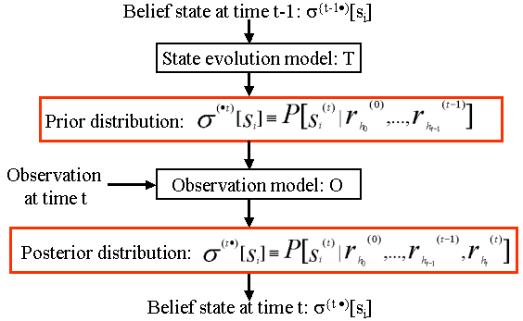 | 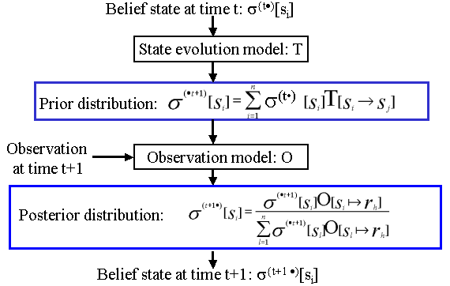
Fig 1. Control flow schematic for the monitoring process

Abstractly, we can view T as a function mapping σ^{(t•)} to σ^{(•t+1)}, and define O_{r(h)} as the function mapping σ^{(•t+1)} to σ^{(t+1•)} upon observing the response r_{h} at time t+1.

While exact monitoring is simple in principle, it can be quite costly. The belief state for a process represented compactly as a DBN is typically exponential in the number of state variables: it is therefore impractical to store the belief state, far less to propagate it through the various update procedures described above.

Thus, we are interested in utilizing compactly represented approximate belief states in our inference algorithm. The risks associated with this idea are clear:
- The errors induced by our approximations may accumulate to make the results of our inference completely irrelevant.
- Spontaneous amplification of the error due to some sort of instability may occur to make the results of our inference meaningless.
The stochasticity of the process prevents these problems from occurring.

The BK Algorithm

The main steps of the BK algorithm is as follows:
- Decide on some computationally tractable representation for an approximate belief state (e.g. one that decomposes into independent factors).
- Propagate the approximate belief state at time t through the transition model and condition it on our evidence at time t+1.
- In general, the resulting state for time t+1 will not fall into the class which we have chosen to maintain. Continue to approximate the belief state using one that does and continue.

Denote $\overset{\text{\sim }}{σ}$^{(t)} the compactly represented approximate belief state at time t. The choice of compact representation depends on the process. If, for example, our process is composed of some number of weakly interacting subprocesses – e.g. several cars on a freeway – it may be reasonable to represent our belief state at a given time using our marginal beliefs about its parts (e.g. individual vehicles).

The approximate belief state $\overset{\text{\sim }}{σ}$^{(t)} is updated using the same process as σ^{(t•)}; we propagate it through the transition model, obtaining $\overset{}{σ}$^{(•t+1)}, and condition on the current response, obtaining $\overset{}{σ}$^{(t+1•)}. However, $\overset{}{σ}$^{(t+1•)} does not usually fall into the same family of compactly-represented distributions to which we chose to restrict our belief states. In order to maintain the feasibility of our update process, we must approximate $\overset{}{σ}$^{(t+1•)}, typically by finding a “nearby” distribution that admits a compact representation; the result is our new approximate belief state $\overset{\text{\sim }}{σ}$^{(t+1)}. In our freeway domain, for example, we may compute our new beliefs about the state of each vehicle by projecting $\overset{}{σ}$^{(t+1•)}, and use the cross product of these individual beliefs as our approximation; the resulting distribution is the closest (in terms of relative-entropy) to $\overset{}{σ}$^{(t+1•)}. In a continuous process, we could project back into our space of allowable belief states by approximating the distribution using a fixed number of Gaussians.

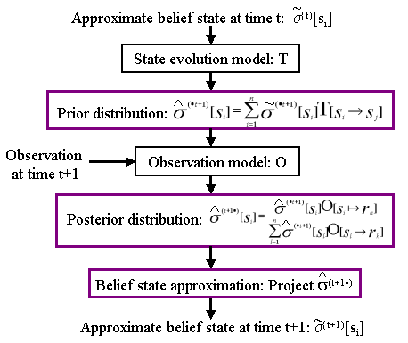
Fig 2. Control flow schematic for the approximate monitoring process via the BK algorithm

Error analysis

We begin by analyzing the error resulting from the approximation strategy, i.e., the distance between the true posterior belief state σ^{(t+1•)} and our approximation to it $\overset{}{σ}$^{(t+1•)}. The distance measure that we employ here is the relative entropy, or KL divergence, which quantifies the loss or inefficiency incurred by using distribution ψ when the true distribution is ϕ:

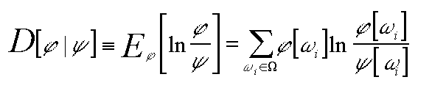
Definition 2. If ϕ and ψ are two distributions over the same space Ω, the relative entropy of ϕ to ψ is:

Intuitively, the approximation error results from two sources: the “old” error that we “inherited” from the previous approximation $\overset{\text{\sim }}{σ}$^{(t)}, and the “new” error derived from approximating $\overset{}{σ}$^{(t+1•)} using $\overset{\text{\sim }}{σ}$^{(t+1)}. Suppose that each approximation introduces an error of ε, increasing the distance between the exact belief state and our approximation to it. However, the contraction resulting from the state transitions:

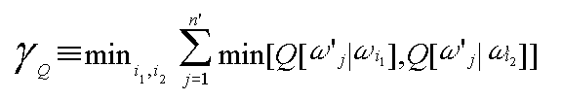
Transition Contraction. For a Markov process with stochastic transition model Q, its minimal mixing rate of Q is:

The stochastic propagation by Q reduces relative entropy by a factor of 1-γ_{Q}.

serves to drive them closer to each other, reducing the effect of old errors by a factor of γ. The various observations move the two even closer together on expectation (averaged over the different possible responses) via the following contraction result:

Observation Contraction. For any t,

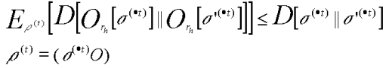
where ρ(t) is the prior on the response at time t.

Therefore, the expected error accumulated up to time t would behave as:
ε + (1-γ) ε + … + (1-γ)^{t+1} ε ≤ ε ∑_{i} (1-γ)^{i} = ε/γ.

The approximation error is defined as the relative entropy distance between the new approximate belief state $\overset{\text{\sim }}{σ}$^{(t)} and the true belief state σ^{(t•)} – D[σ ^{(t•)} || $\overset{\text{\sim }}{σ}$^{(t)}]. We are now ready to quantify the error resulting from our approximation:

Definition 3. We say that an approximation $\overset{\text{\sim }}{σ}$^{(t)} of $\overset{}{σ}$^{(t•)} incurs error ε relative to σ^{(t•)} if
D[σ ^{(t•)} || $\overset{\text{\sim }}{σ}$^{(t)}] – D[σ ^{(t•)} || $\overset{}{σ}$^{(t•)}] ≤ ε

Bounded Error Theorem. Let T be a stochastic process whose mixing rate is γ, assume that we have an approximation scheme that, at each phase t, incurs error ε relative to σ^{(t•)}. Then: E_{ρ(1,…,t)}[D[σ ^{(t•)} || $\overset{\text{\sim }}{σ}$^{(t)}]] ≤ ε/γ
where the expectation is taken over the possible response sequence r_{h(1)},…, r_{h(t)}, with the probability ascribed to them by the process T.

The above theorem provides the following guarantees:
- The bound involves relative entropy between the two entire belief states.
- Note that the bounds are on the expected error; the error for specific sequences of evidence are much weaker. In particular, the error after a very unlikely sequence of evidence might be quite large. Fortunately, the contraction results holds for arbitrary distribution, no matter how far apart. Thus, even of momentarily σ^{(t•)} and $\overset{\text{\sim }}{σ}$^{(t)} are very different, the contraction property will reduce this error exponentially.

Implementation considerations

In order to apply this procedure to a particular problem, we must define a partition of the canonical variables, i.e. choose a partition of the process into subprocesses. The tradeoff in the partitioning is subtle: Subprocesses with a small number of state variables allow more efficient inference. They also have a smaller transition matrix and therefore their mixing rate is likely to be better. On the other hand, our subprocesses need to be large enough so that there are no edges between subprocesses within a single time slice. Furthermore, making our subprocesses too small increases the error incurred by the approximation of assuming them to be independent. Specifically, if we have two (sets of) variables that are highly correlated, splitting them into two separate subprocesses is not a good idea. The following experimental results illustrate these tradeoffs.

Experimental results

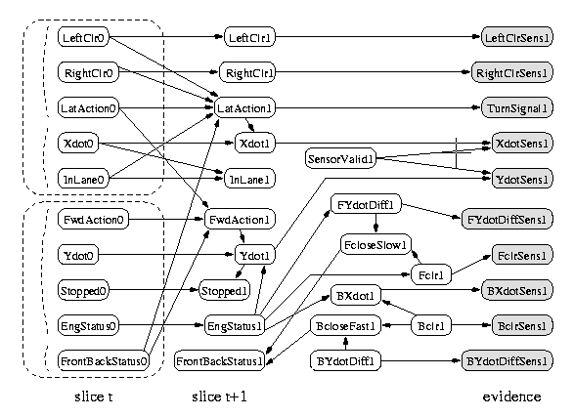
The algorithm is validated in the context of real-life DBNs, one of which is the BAT network, used for monitoring freeway traffic.

Fig 3. BAT network

The experimental methodology is as follows: starting from the same initial prior, the process is monitored using the approximate method with some fixed decomposition, and the performance is compared with the result derived from exact inference at every t. Observations are simulated by sampling the evidence variables according to the exact distribution.

Figure 4(a) shows the evolution of the relative entropy for the BAT network on a typical run, using all the shadowed nodes on the right hand side of Figure 3 as evidence nodes. In the network, the canonical belief state consists of 10 variables roughly partitioned in two weakly interacting groups of 5. On an UltraSparc 2, the approximate monitoring took about 0.11 seconds per time slice, as compared to 1.72 for the exact inference, yielding a 15-fold speedup. In terms of accuracy, the error averages 0.0007, remaining very low most of the time with a few sparsely distributed spikes (corresponding to unlikely evidence) to somewhat larger value, peaking at about 0.065. The spikes do not grow over the length of the run, as predicted by the analysis.

To investigate the effect of our approximate belief state representation, different approximation clusterings are attempted. The results are shown in Figure 4(b) (averaged over 8 different runs and plotted on logarithmic scale). The lower curve corresponds to the “5+5” clustering used above: at an average error of 0.0006, its error is always lower than a “3+5+4+1” clustering obtained by further breaking down each of the 5-clusters (middle curve) for which the error averages 0.015 (and whose speedup is 20 compared to 15). Both are clearly more superior to the third case, a “3+2+4” clustering that bears no relationship to the connectivity of the variables of the network, and for which the average error reaches 0.14 (with a comparable speedup of 20).

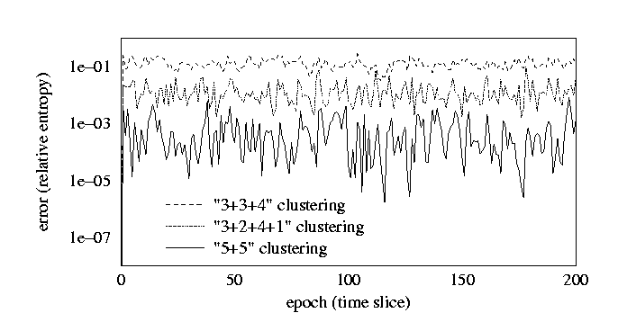
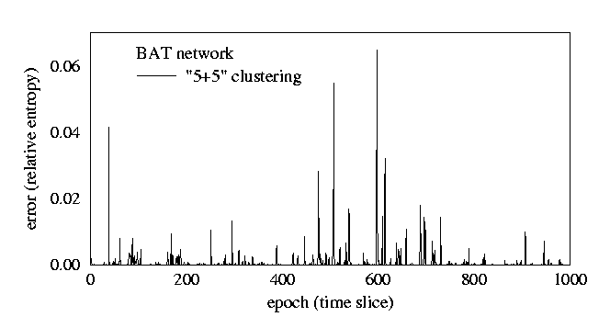
Fig 4(a): Error plot for the “5+5” clustering | Fig 4(b): Error plot for the different clusterings

Conclusion

In [Boyen & Koller, 1998], the effect of approximate inference in a stochastic process is investigated. The stochastic nature of the process tends to make errors resulting from an approximation disappear rapidly as the process continues to evolve. This idea is applied to the task of monitoring a stochastic process, i.e., continuously maintaining a belief state over the state at the current time. This task is known to be infeasible in complex stochastic processes involving a large number of subprocesses, since exact inference is forced into intractability by full correlation of the belief state that occurs even in highly structured processes. The BK approach allows the approximate belief state be maintained in a way that guarantees that the error from successive approximations do not accumulate. Indeed, the error from the approach is significantly reduced in processes in which the structure of the approximation matches well to the structure of the process. Empirical results have shown that this approach works extremely well on real-life processes. Indeed, order of magnitude savings are achieved at the cost of a very low error in the approximation.

References

Tractable Inference for Complex Stochastic Processes
Xavier Boyen & Daphne Koller
UAI’1998
Technical report (1998)

Exploiting the Architecture of Dynamic Systems
Xavier Boyen & Daphne Koller
Technical report (1999)

Sampling in Factored Dynamic Systems
Daphne Koller & Uri Learner
Technical report (2000)

Code Distribution

The code for the BK method of approximate inference is distributed as part of Kevin Murphy’s Matlab Bayesian network toolbox. The toolbox can be downloaded from:
http://www.cs.berkeley.edu/~murphyk/Bayes/bnt.html

